1. Identify all the different components you know in the following motherboards.

Number 1

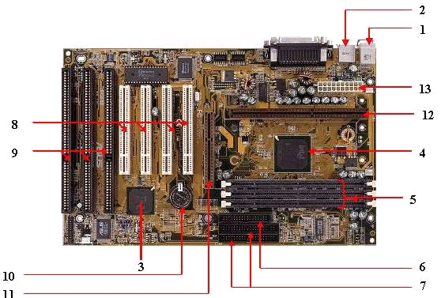

1. Ethernet
2. Video output
3. Southbridge
4. nortbridge
5. RAM slots
6. Floppy conector
7. IDE conector
8. PCIe x8 conectors
9. PCIe x16 conectors
10. CMOS battery
11. AGP conector
12. CPU slot
13. POWER ATX conector

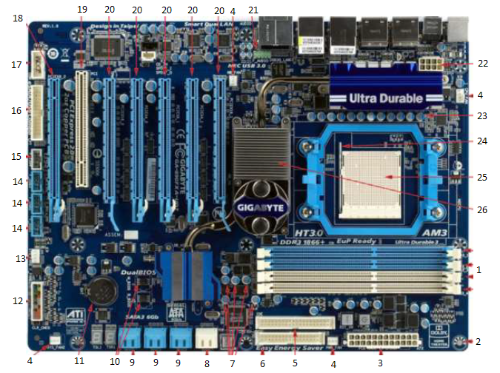

- RAM DIMM slots
- Screw hole
- ATX power connector
- 3-pin fan header
- IDE connector
- Floppy connector
- Capacitors
- SATA2 connector
- 3x SATA3 connectors
- Dual BIOS
- CMOS battery
- Front panel connectors
- 4-pin PWM fan header
- 3x front panel USB 2.0
- Front panel audio connector
- USB 3.0 front panel connector
- Front panel audio connector
- PCIe x16
- PCI x8
- 5x PCIe x16 slots
- Jumper
- CPU power connector
- VRM capacitors
- J
- PGA CPU socket
- Northbridge

Number 3

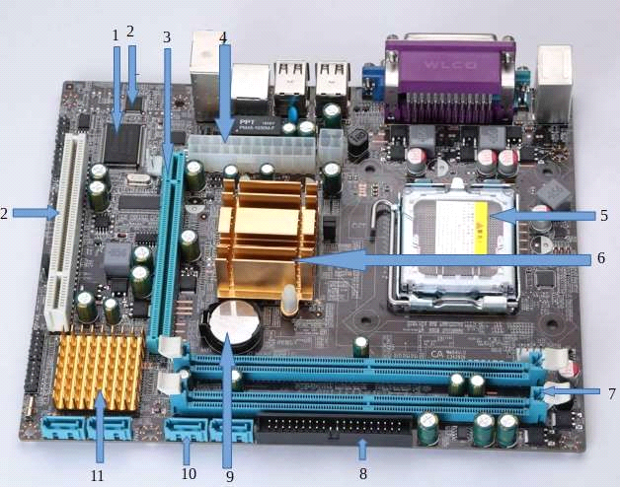
- BIOS
- PCI
- PCIe x16
- ATX Power
- CPU Socket
- Northbridge
- RAM slots
- IDE connector
- CMOS battery
- SATA port
- Southbridge

Number 4

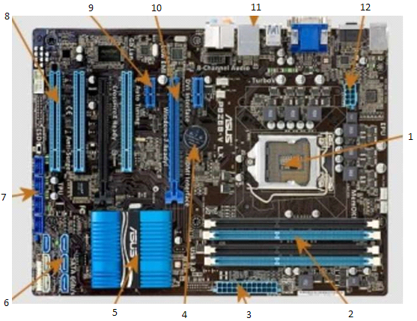

- LGA CPU socket
- RAM DIMM slots
- ATX power connector
- CMOS battery
- Northbridge
- SATA connectors
- USB 2.0 front panel connectors
- PCI
- PCIe 1x or 2x
- PCIe x16
- Back IO (probably ethernet)
- CPU power connector

2. Identify the external connectors in the following pictures

Number 1

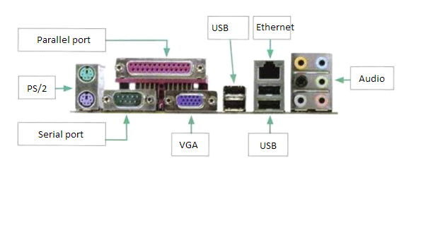

Number 2

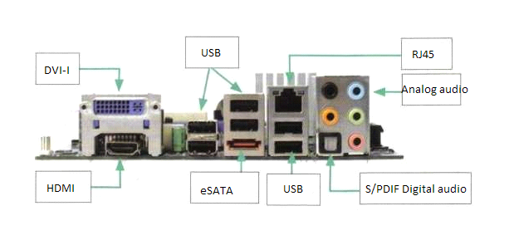

Number 3

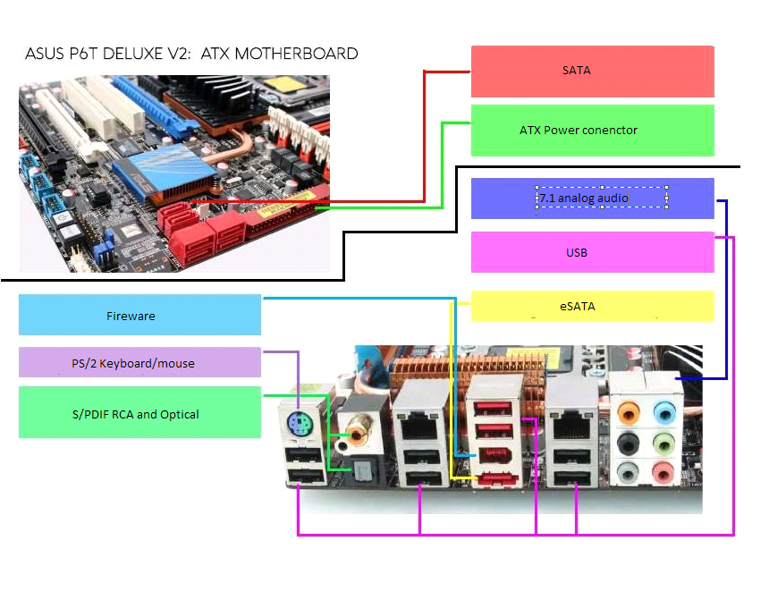

Number 4

